SETUPENVIRONMENT:

FLASKCREATION

|  |  |
| --- | --- |
| TEAMID | PNT2022TMID50435 |
| COLLEGE | PSN ENGINEERING COLLEGE, MELATHIDIYOOR, TIRUNELVELI |
| TEAMLEAD | TAMIL SELVAN |
| TEAMMEMBER01 | ARUN VIGNESH |
| TEAMMEMBER02 | MATHESH SUDHARSAN |
| TEAMMEMBER03 | MOSAI |

Flaskinstall

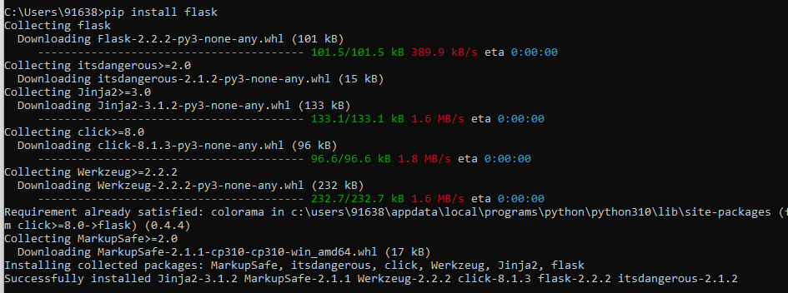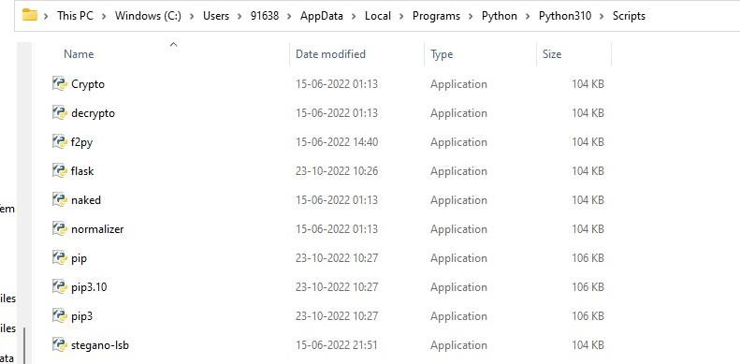

Createflask:

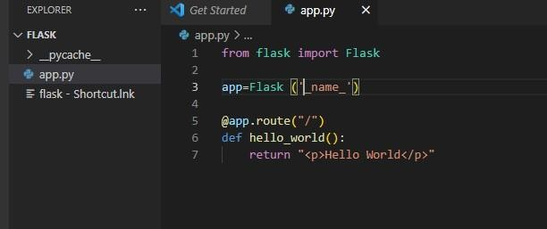

Runflak:

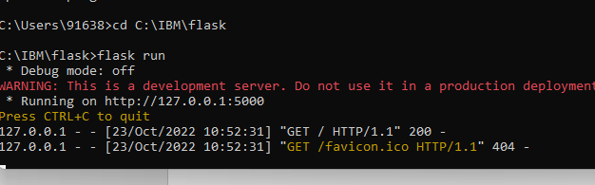

Output

